**Walmart Weekly Sales**

**Postgres SQL ETL Documentation**

Data Sets: Data is extracted from the Kaggle Walmart Retail Analytics Competition as CSV files. A total of 3 data sets; sales data-set.csv, Features data set.csv, and stores data-set.csv. An additional CSV file, holidays.csv, was created in Excel to help identify which holiday fell on a given date.

ETL Objectives:

* Create new PostgreSQL database in PGAdmin called retail_db, with Schema for 4 tables developed in Quick Database Diagrams.
* Extract all 4 CSV files to a different Pandas Dataframe in Jupyter Notebooks.
* Transform each Dataframe to match to Schema for PostgreSQL retail_db database.
* Load transformed Dataframes to PostgreSQL retail_db, via Pandas to_sql function and SQLAlchemy in Jupyter Notebook.

**Data Extraction**

* Jupyter Notebook created for Project.
* Dependencies:
  + Pandas
    - Dataframe Functions
  + Datetime
    - Formatting Dates
  + SQLAlchemy (create_engine)
    - Load Dataframes into
  + Config (File)
    - Contains PGAdmin Password
* Extracted All 4 CSV files via Pandas read_csv function

**Features data set.csv Transformation**

* Check Data Types & Display Dataframe Pre-Transformation:

* Select all columns and copy Dataframe.

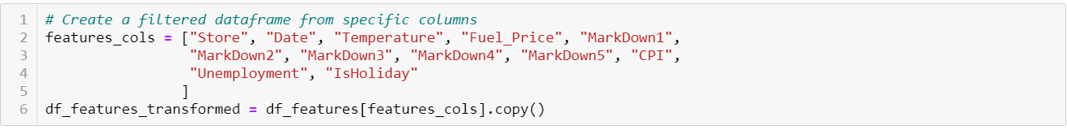

- Convert Date to Datetime: yyyy/mm/dd

-Convert Column “Store” to string

-Round all Float Data Types to 2 decimal places

-Replace all NaN values to 0.0

-Rename columns to include underscores for spacing.

-Map and lowercase all column headers to ensure column headers match PostgreSQL Schema

- Display Transformed Dataframe and Data Types

**sales data-set.csv Transformation**

**-**Check Data Types & Display Dataframe Pre-Transformation:

**-** Select all columns and copy Dataframe.

-Convert Column “Store” and “Dept” to String

-Rename Column “IsHoliday” with underscore

-Convert Column “Date” to Datetime: yyyy/mm/dd

-Map and lowercase all column headers to ensure column headers match PostgreSQL Schema

- Display Transformed Dataframe and Data Types

**Holiday.csv Transformation**

-Check Data Types & Display Dataframe Pre-Transformation:

-Select all columns and copy Dataframe.

-Convert Column “Date” to Datetime: yyyy/mm/dd

-Map and lowercase all column headers to ensure column headers match PostgreSQL Schema

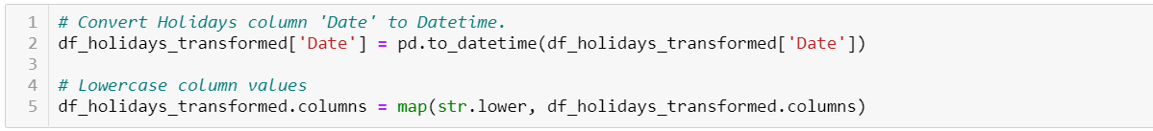

- Display Transformed Dataframe and Data Types

**Stores data-set.csv Transformation**

- Check Data Types & Display Dataframe Pre-Transformation:

-Select all columns and copy Dataframe.



-Convert Column “Store” to String

-Map and lowercase all column headers to ensure column headers match PostgreSQL Schema

- Display Transformed Dataframe and Data Types

**PostgreSQL Database & Schema**

-Quick Database Diagrams was used to create retail_db Schema.

-Create Table Statements:

**Load to PostgreSQL Database**

-Create Database Connection to PostgreSQL retail_db

-Confirm available tables in PostgreSQL retail_db

**-** Load Transformed Dataframes into PostgreSQL retail_db

